Szymon Mirr 124B

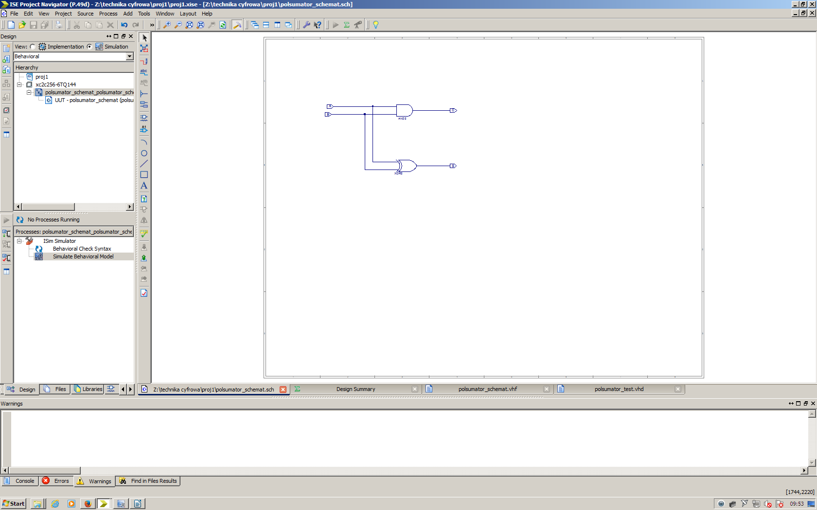
--------------------------------------------------------------------------------
-- Copyright (c) 1995-2012 Xilinx, Inc. All rights reserved.
--------------------------------------------------------------------------------
-- ____ ____
-- / /\/ /
-- /___/ \ / Vendor: Xilinx
-- \ \ \/ Version : 14.4
-- \ \ Application : sch2hdl
-- / / Filename : polsumator_schemat.vhf
-- /___/ /\ Timestamp : 04/04/2016 09:01:34
-- \ \ / \
-- \___\/\___\
--
--Command: C:\Xilinx\14.4\ISE_DS\ISE\bin\nt\unwrapped\sch2hdl.exe -intstyle ise -family xbr -flat -suppress -vhdl polsumator_schemat.vhf -w "Z:/technika cyfrowa/proj1/polsumator_schemat.sch"
--Design Name: polsumator_schemat
--Device: xbr
--Purpose:
-- This vhdl netlist is translated from an ECS schematic. It can be
-- synthesized and simulated, but it should not be modified.
--

library ieee;
use ieee.std_logic_1164.ALL;
use ieee.numeric_std.ALL;
library UNISIM;
use UNISIM.Vcomponents.ALL;

entity polsumator_schemat is
port ( A : in std_logic;
B : in std_logic;
C : out std_logic;
S : out std_logic);
end polsumator_schemat;

architecture BEHAVIORAL of polsumator_schemat is
attribute BOX_TYPE : string ;
component AND2
port ( I0 : in std_logic;
I1 : in std_logic;
O : out std_logic);
end component;
attribute BOX_TYPE of AND2 : component is "BLACK_BOX";

component XOR2
port ( I0 : in std_logic;
I1 : in std_logic;
O : out std_logic);
end component;
attribute BOX_TYPE of XOR2 : component is "BLACK_BOX";

begin
XLXI_1 : AND2
port map (I0=>B,
I1=>A,
O=>C);

XLXI_2 : XOR2
port map (I0=>B,
I1=>A,
O=>S);

end BEHAVIORAL;

a | b | c | s
0 | 0 | 0 | 0
0 | 1 | 0 | 1
1 | 0 | 0 | 1
1 | 1 | 1 | 0

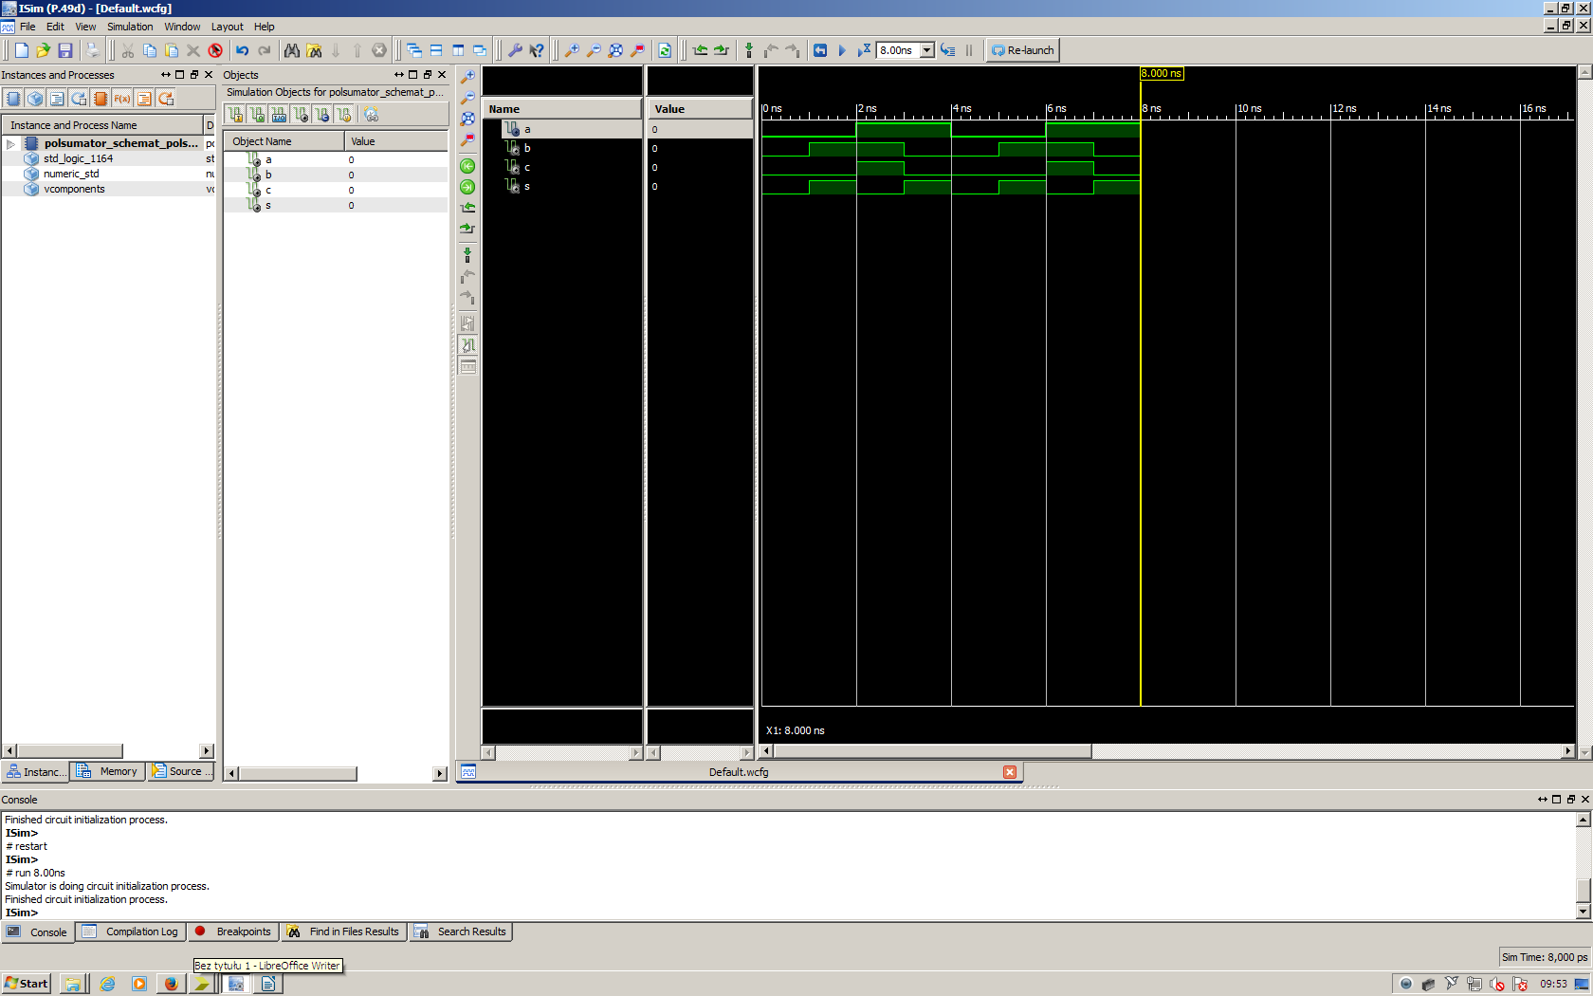

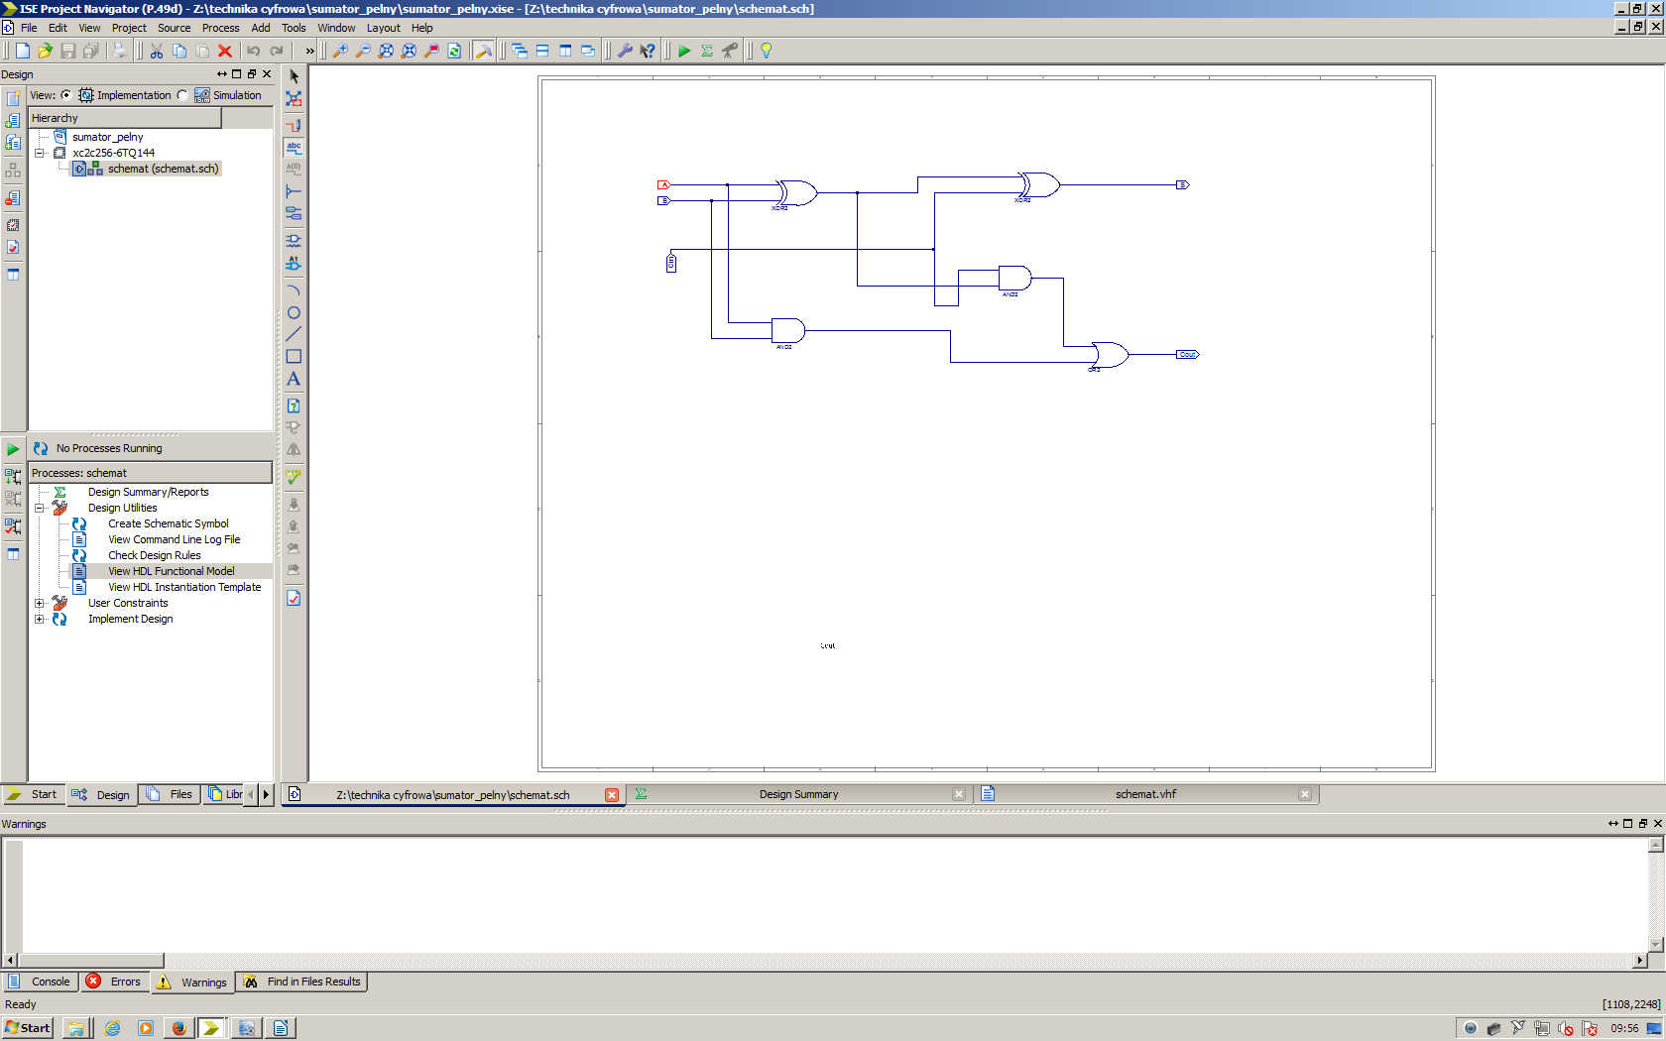
--------------------------------------------------------------------------------
-- Copyright (c) 1995-2012 Xilinx, Inc. All rights reserved.
--------------------------------------------------------------------------------
-- ____ ____
-- / /\/ /
-- /___/ \ / Vendor: Xilinx
-- \ \ \/ Version : 14.4
-- \ \ Application : sch2hdl
-- / / Filename : schemat.vhf
-- /___/ /\ Timestamp : 04/04/2016 09:56:09
-- \ \ / \
-- \___\/\___\
--
--Command: C:\Xilinx\14.4\ISE_DS\ISE\bin\nt\unwrapped\sch2hdl.exe -intstyle ise -family xbr -flat -suppress -vhdl schemat.vhf -w "Z:/technika cyfrowa/sumator_pelny/schemat.sch"
--Design Name: schemat
--Device: xbr
--Purpose:
-- This vhdl netlist is translated from an ECS schematic. It can be
-- synthesized and simulated, but it should not be modified.
--

library ieee;
use ieee.std_logic_1164.ALL;
use ieee.numeric_std.ALL;
library UNISIM;
use UNISIM.Vcomponents.ALL;

entity schemat is
port ( A : in std_logic;
B : in std_logic;
Cin : in std_logic;
Cout : out std_logic;
S : out std_logic);
end schemat;

architecture BEHAVIORAL of schemat is
attribute BOX_TYPE : string ;
signal XLXN_8 : std_logic;
signal XLXN_9 : std_logic;
signal XLXN_13 : std_logic;
component XOR2
port ( I0 : in std_logic;
I1 : in std_logic;
O : out std_logic);
end component;
attribute BOX_TYPE of XOR2 : component is "BLACK_BOX";

component AND2
port ( I0 : in std_logic;
I1 : in std_logic;
O : out std_logic);
end component;
attribute BOX_TYPE of AND2 : component is "BLACK_BOX";

component OR2
port ( I0 : in std_logic;
I1 : in std_logic;
O : out std_logic);
end component;
attribute BOX_TYPE of OR2 : component is "BLACK_BOX";

begin
XLXI_1 : XOR2
port map (I0=>B,
I1=>A,
O=>XLXN_13);

XLXI_2 : XOR2
port map (I0=>Cin,
I1=>XLXN_13,
O=>S);

XLXI_3 : AND2
port map (I0=>B,
I1=>A,
O=>XLXN_8);

XLXI_4 : AND2
port map (I0=>XLXN_13,
I1=>Cin,
O=>XLXN_9);

XLXI_5 : OR2
port map (I0=>XLXN_8,
I1=>XLXN_9,
O=>Cout);

end BEHAVIORAL;

a | b | cin | cout | s
0 | 0 | 0 | 0 | 0
0 | 0 | 1 | 0 | 1
0 | 1 | 0 | 0 | 1
0 | 1 | 1 | 1 | 0
1 | 0 | 0 | 0 | 1
1 | 0 | 1 | 1 | 0
1 | 1 | 0 | 1 | 0
1 | 1 | 1 | 1 | 1

